**Data Enrichment and Consolidation Gateway**

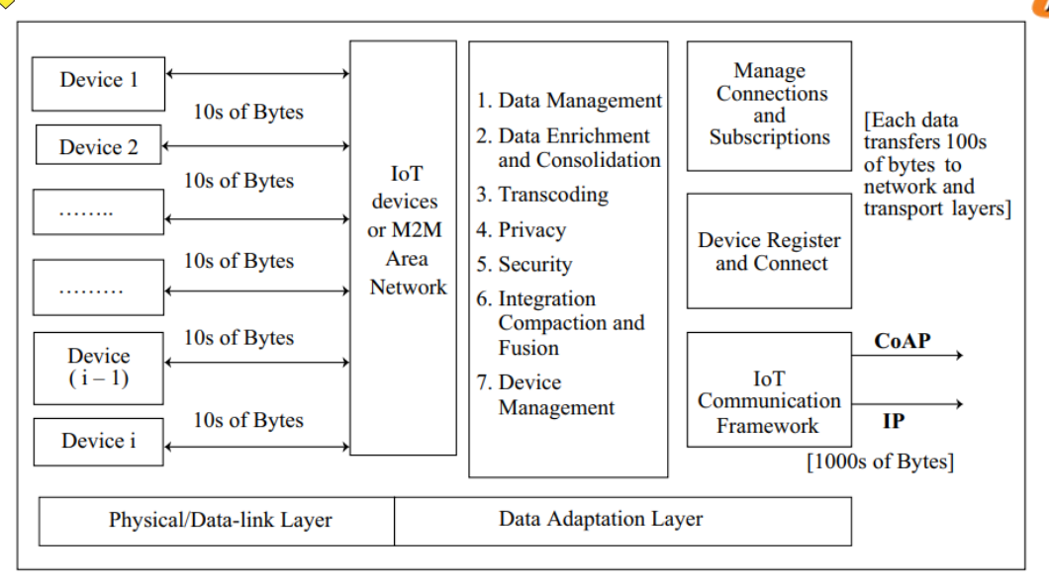

IoT or M2M gateway consisting of data enrichment and consolidation, device management and communication frameworks at the adaptation layer

Gateway includes the provisions for one or more of the following functions: transcoding and data management. Following are data management and consolidation functions:

● Transcoding

● Privacy, security

● Integration

● Compaction and fusion

**Transcoding:**

Transcoding means data adaptation, conversion and change of protocol, format or code using software. The gateway renders the web response and messages in formats and representations required and acceptable at an IoT device. Similarly, the IoT device requests are adapted, converted and changed into required formats acceptable at the server by the transcoding software.

**Privacy:**

Data such as patient medical data, data for supplying goods in a company from and to different locations, and changes in inventories, may need privacy and protection from conscious or unconscious transfer to untrustworthy destinations using the Internet.

Privacy is an aspect of data management and must be remembered while designing an application. The design should ensure privacy by ensuring that the data at the receiving end is considered anonymous from an individual or company.

**Aggregation** refers to the process of joining together present and previously received data frames after removing redundant or duplicate data.

**Compaction** means making information short without changing the meaning or context; for example, transmitting only the incremental data so that the information sent is short.

**Fusion** means formatting the information received in parts through various data frames and several types of data (or data from several sources), removing redundancy in the received data and presenting the formatted information created from the information parts. Data fusion is used in cases when the individual records are not required and/or are not retrievable later

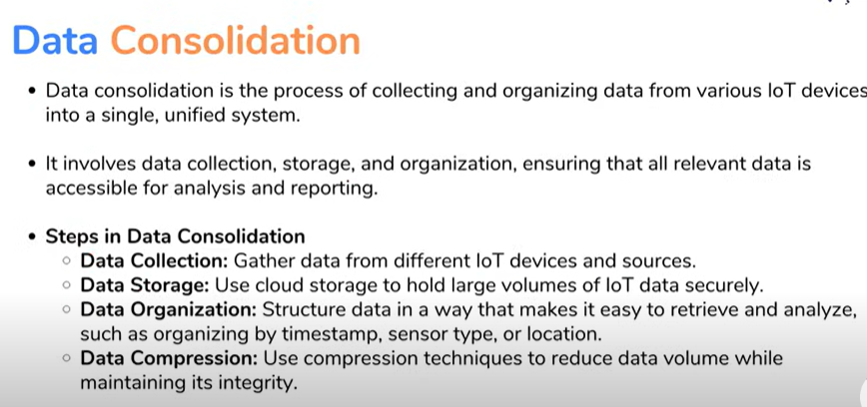

**Device Management Gateway:**

Device Management (DM) means provisioning for the device ID or address which is distinct from other resources, device activating, configuring (managing device parameters and settings), registering, deregistering, attaching and detaching.

Device management also means accepting subscription for its resources. Device fault management means course of actions and guidelines to be followed in case if a fault develops in the device.

Open Mobile Alliance (OMA)-DM and several standards are used for device management. OMA-DM model suggests the use of a DM server which interacts with devices through a gateway in case of IoT/M2M applications. A DM server is a server for assigning the device ID or address, activating, configuring (managing device parameters and settings), subscribing to device services or opting out of device services and configuring device modes.

A device instead of a DM server, communicates to a gateway in case of low-power loss environment.

**Gateway functions for device management are:**

● Does forwarding function when the DM server and device can interact without reformatting or structuring

● Does protocol conversion when the device and DM server use distinct protocols

● Does proxy function in case an intermediate pre-fetch is required in a lossy environment or network environment needs

**Ease of designing and affordability:**

Design for connected devices for IoT applications, services and business processes considers the ease in designing the devices’ physical, data-link, adaption and gateway layer.

It means availability of SDKs (software development kits), prototype development boards with smart sensors, actuators, controllers and IoT devices which are low in cost and hardware which embeds and are preferably open source software components and protocols. Hardware which includes the device should embed minimum number of components and use ready solutions for ease in designing local devices personal area network and secure connectivity with the Internet.

Designing also considers ease as well as affordances for example, RFID or card. The card has an embedded microcontroller, memory, OS, NFC peripheral interfaces, access point-based device activation, RF module and transceiver at low cost.

